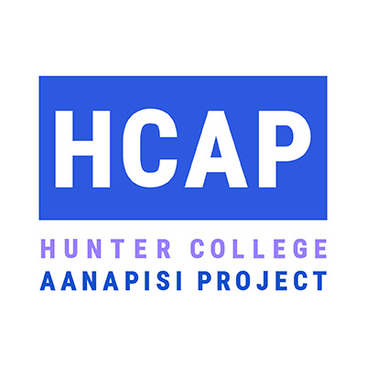

HCAP Student Leadership Internship Application Instructions (Fall 2019 Semester):

- Review the HCAP Leadership Internship Overview Document

- Fill out the HCAP Leadership Internship Application

- By April 29th: send your application and resume via email to Caitlin Ho, HCAP Program Director: ch1322@hunter.cuny.edu

HCAP Leadership Internship Program Application
Due: 4/29/19 for Fall 2019 Semester

Name:

Email (please note email you regularly check):
Phone:
Major(s):
Minors (if applicable):
Expected Graduation (Spring or Fall, Year):

Have you completed the pre-reqs for this program? (ENGL 120 or ASIAN 210) – Yes / No
Have you taken at least 1 ASIAN course? If so, which one(s)?:

- What Asian American issue areas or community topics are you interested in exploring during your internship experience?

- What skills would you like to develop during your internship experience? (ie: public speaking, event planning, research and writing, etc.)

- Are there particular careers or fields you are considering working in after graduating? If so, which ones?

- Once accepted to the HCAP Leadership Internship Program, you may register for the ASIAN 29000 Leadership Internship course for credit. If you plan to take the course for credit: are you planning to take it for 3 credits (1 semester) or 6 credits (2 semesters?)

- All HCAP interns are required to work at least 10 hours per week during the semester (ideally, two days per week). What days of the week and times are you available to work at your internship placement?

- Do you speak, read, or write in any languages other than English? If so, which languages and what level of fluency do you have?

Please include your most up to date resume. For examples, please see Hunter’s Career Development Services page (specific link here)

